Inchicore NS
September Newsletter 2021 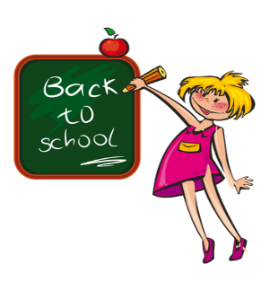
Welcome
Welcome back to everyone in our school community, especially to our new Junior Infant pupils. Welcome also to Ms. Phelan and Ms Ni Lochlainn who have recently joined the school staff and best wishes to Mrs Hallissey as she begins her maternity leave.
School Calendar 2020/2021
The school calendar can be viewed on the school website.
Please note that the school will be closing at 12pm on Friday the 15th of October due to staff training for the Primary Language Curriculum.
Creativity in the Classroom 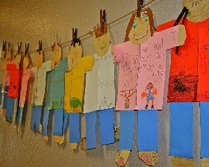
Our two First Classes recently started a six week project called Creativity in the Classroom.
This is a project which grew out of the Canal Communities Partnership’s attempt to address social and educational disadvantage in a dynamic way, with the hope of eventually impacting on early school leaving endemic in our area. Through the visual arts, children are given an opportunity to have new learning experiences, an exposure to learning in a creative way, and at the same time exploring concepts and ways of working individually and collectively.
“This week, our class went to the park & explored, we looked for different things that reminded us of nature. We had so much fun creating wonderful art from different things with Liz! Then we used our collections to make portraits! See our website page for some wonderful creations (& discoveries!) Ms. Gleeson 1st class teacher
Healthy Lunches
As you are aware, we have a healthy lunch policy in operation in Inchicore NS
Friday is treat day. On Fridays children may bring in ONE treat item. Fizzy drinks are not permitted.
Please be aware that quite a lot of lunch items available are “dressed-up” as healthy, nutritious foods but which, in reality are laced with sugar and other additives.
We are a Green School, all packaging and uneaten food must be brought home each day. If your child is getting a school lunch they should not be bringing in their own lunch also. Where this is happening the school lunch will be cancelled.

Advice on healthy lunches can be found on our website at this link: https://www.safefood.net/education/healthy-lunchboxes

Thanks, as always, for your co-operation in this matter.
First Holy Communion
- First Confession will take place on Thursday the 30th of September.
- The First Communion Ceremony takes place on Saturday 16th October at 2pm
- County Photos will come to the school on Monday, 18th of October to take photos.
- Confirmation for last year’s 6th class will take place on November 13th at 12pm
Please keep in mind the government advice about visitors and social gatherings which you can read here: https://www2.hse.ie/conditions/coronavirus/protect-yourself-and-others.html
Aladdin Connect
Aladdin Connect is the messaging service that we will be using for the coming year.
You will be receiving details about how to sign up to the app in the coming weeks. This service is fully integrated with attendance data, report cards, permissions for school activities and trips etc. Phone numbers, personal data like medical information, change of address can be done by you on the app.
Book Rental and Pupil Insurance can also be paid online through Aladdin once the system is set up.
Be on Time-Ten to Nine!
Please ensure your children arrive on time for school. The schools gates are closed at 9.10am.
Gates open at 8.40am. Children arriving before this time must remain under the supervision of parents/guardians.
Children arriving late must come to the red door on Sarsfield Rd. where the arrival time will be recorded. Early collection cannot be accommodated apart from exceptional circumstances and with prior notice. Collection of children can be very disruptive to their learning, the learning of others and the school office. Kindly notify your child’s teacher if your child has an appointment. Children will only be called from their classes when their parent arrives at the front office to collect them.
Thank you for your cooperation with this matter.
Attendance at school is vitally important. However, we would like to thank parents and guardians for their consideration in not sending children to school if they are ill. This goes a long way to keeping everyone safe. For the most recent up to date information on when to keep your child home from school, please visit the HSE website on the following link https://www2.hse.ie/conditions/covid19/preventing-the-spread/keep-your-child-home/
Inchicore Works Art Competition 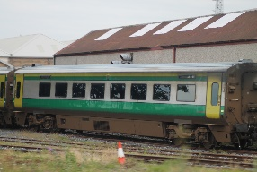
Last June, Inchicore Works held an art competition to design one of their new trains.
Congratulations to Lily, Arianna, Migle, Neillí, Aoife, Raia, Lucy, Miguel, Katie and Alex who were the class winners.
The unveiling of the new train with all the childrens’ artwork will take place later this month and RTE will be filming it as part of a special ‘Nationwide’ episode to celebrate the 175th anniversary of the Inchicore Works.

Contact Details Please ensure the school has an up to date personal email address and contact numbers of parents / guardians / childminders so easy contact can be made in the event of a child becoming unwell in school and for text-a-parent purposes. Parents should use their personal email address as opposed to a work email address. This is important every year and it is even more so this year.

School Uniforms It is great to see all the children turned out so well in their uniforms. Kindly take note of your child’s P.E. days this term. The school tracksuit should only be worn on these days unless otherwise notified by the class teacher. School crests can be bought from the school for €5. All other elements of the school uniform can be purchased in Topstore or other retailers. Also, please ensure all jumpers/cardigans are clearly labelled.
Remember to check your child’s hair regularly for outbreaks of head lice and ensure long hair is tied back!
Medical and Allergy Information
If your child has any medical condition, allergy or food intolerance that we should be aware of, please let us know so we can update our files.
Home-School Communication
As in-school meetings can not take place, class teachers will send a brief outline to parents via email with information about homework, PE days etc.
Class teachers can be contacted through Google Classroom or via email. The drop off and collection time is very busy and staff are needed for supervision to ensure the safety of the children so please try not to use this time to deliver messages or ask questions.
If you need to update your child’s file in the school office, kindly email Miriam at office@inchicorens.ie
Parents Council AGM
The Parents Council AGM will be held in a couple of weeks. Unfortunately, due to Covid restrictions we will not be in a position to facilitate a face to face meeting so it will take place through zoom.
If you are interested in attending, please email the HSCL Jacqueline Garvin at jgarvin@inchicorens.ie and she will give you the details.

