Inchicore NS  HSCL  Summer Newsletter  June 2021 | 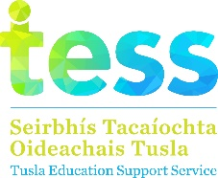
Junior Infant News  We visited the school allotment last month and really enjoyed seeing all the lovely plants growing there. We have also been taking care of caterpillars in the classroom which we hope to release when they become butterflies.  Sen. Infant News (Ms Bohan)  Senior Infants visited the allotment recently to see what is growing there. We also planted our own cress seeds which we got to take home last week. We have been working very hard during our writing workshops on our drafts and then final pieces of writing. We have also been enjoying learning some tennis skills.  Sen. Infants (Ms Gillespie)  We have been learning about mini-beasts in Science and are working hard on the literacy strategy of visualising when we are doing our English writing. We are really looking forward to our Teddy Bear’s picnic next week.  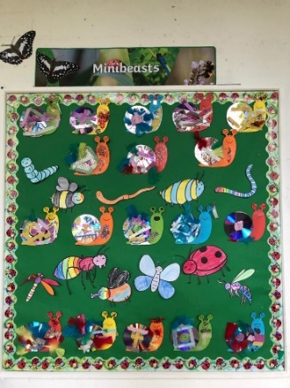  2nd Class (Mr Keane)  Well done to all Mr Keane’s 2nd class who have been learning all about Africa over the last month. Everyone completed two projects, one of a country of their choice and an African animal of their choice. Congratulations to Poppy May Cody who recently entered and won a recent art competition which was run by Cruinniú na nÓg along with Brown Bag Films. Well done Poppy!  2nd Class (Ms Ward)  We really enjoyed learning all about Africa this term and working on interesting projects. Congratulations to Raia who recently won a trophy for his participation in Mathletics. Well done Raia!  4th Class News  We have been enjoying our trips to the allotment over the past few weeks and loved trying out the garlic and radishes that we grew over there. We have also been enjoying our trips to Richmond Park.  “St Pats was really fun. We did lots of running and played football at the end of the training. The people were really nice. We also had a quiz and if you got an answer right you got to shoot in a bucket to score points”  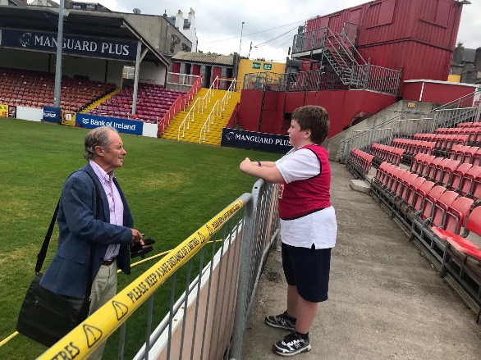  5th Class News  We have been very busy recently taking part in the Junior Achievement program which we enjoyed very much.  We also have been to visit Richmond Park and have been working on the Blue Star programme.  The Blue Star Program  “The Blue Star program was a series of projects and quizzes we did throughout the year to learn more about the EU. We also enjoyed making EU timelines. I really liked learning from the Blue Star Program and would defininitly do it again”.  Maebh  Sixth Class News  We had great fun on Friday with the CP Adventure company. We did lots of activities like tug of war, archery, bush craft skills, team tasks and farm challenges. We also attended a virtual STEAM art workshop and a virtual tour of Croke Park recently. (STEAM- Science, Technology, Engineering, Art, Maths)  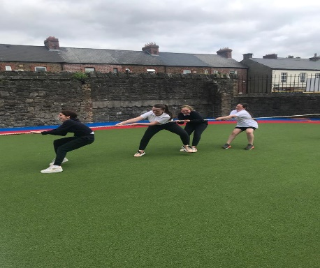  Bee Loud Glade Project  “We were delighted to be a part of the Bee Glade initiative recently, with other pupils from 4th and 5th class  We walked to Chapelizod, where we were joined by pupils from two other schools from Ballyfermot and Palmerstown. We planted a wild flower meadow to attract bees.  After we planted the wild flower seeds we all re cited a poem called The Lake Isle of Inisfree by William Butler Yeats’ to remind us of nature all around us. Soon after wards Councillor Vincent Jackson and Rev Father Pater Jackson unveiled a blue plaque saying Bee Loud Glade and congratulated us for taking part. We cheered and applauded when we saw our school name. We can’t wait to see the flowers bloom.”  Mishka & Katie  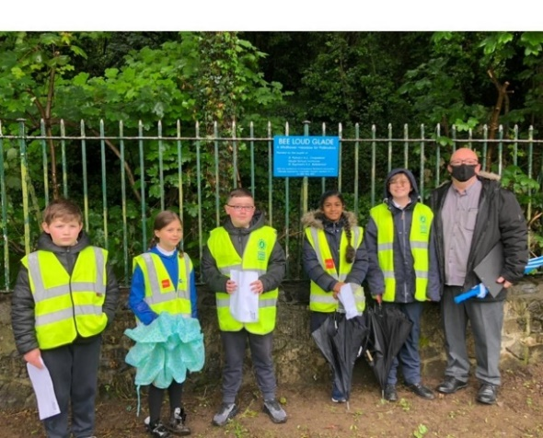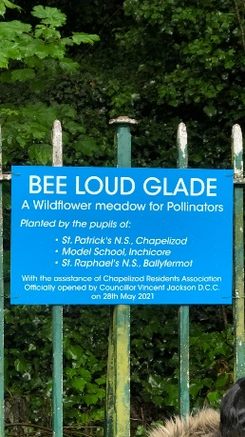  Allotment  Our school allotment has been getting lots of visits this term. The May rain and the recent warm weather has brought so much growth. We have radishes, garlic, lettuces and potatoes ready to eat. There are tomato plants, strawberries, beetroots and onions making great progress in the ground. Special thanks to Gary for all his help on the garden this year. Many thanks also, to the parents who have volunteered to help over the Summer months.  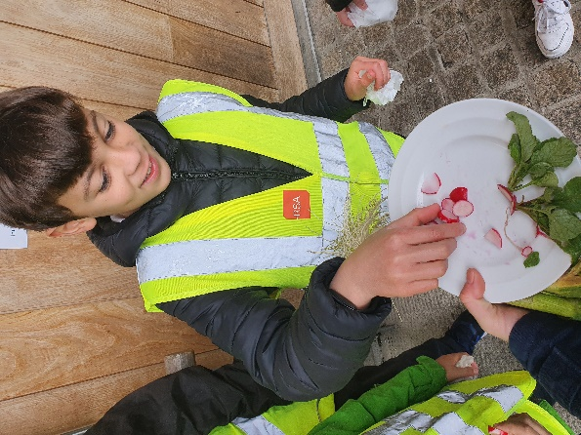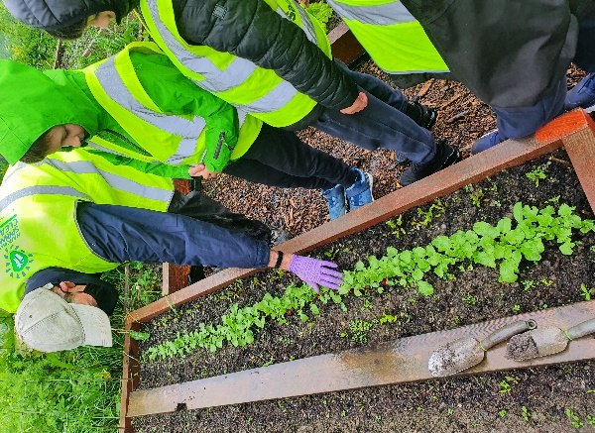  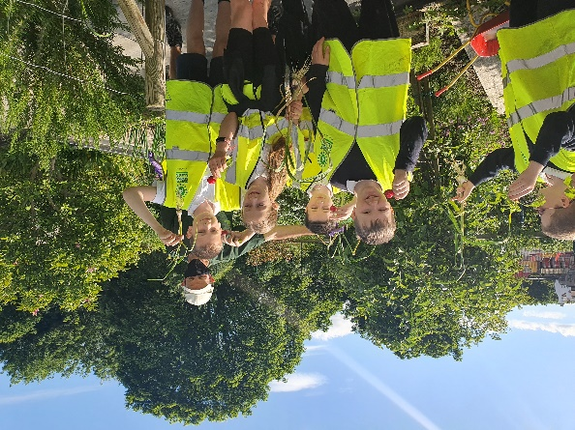  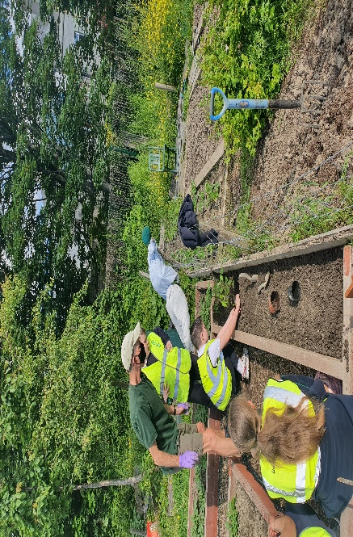 | Holidays  We will close for the Summer Holidays on Wednesday the 30th of June at 12pm and will reopen on Monday, 30th August.  Communion and Confirmation 2021  Communion will take place for 3rd class on July 10th.  2nd class and 6th class will make their Confirmation and Communion in the Autumn.  School Lunches  We are trialling different hot food options at the moment and look forward to getting feedback from both pupils and parents.  Graduation  Our 6th class pupils will graduate from Inchicore NS with a special ceremony in the school hall on Monday 28th June. The event will be recorded for parents to watch.  Junior Achievement  5th and 6th class recently took part in the Junior achievement program.  “Junior Achievement is a program about running a business. We all came up with ideas for a product or service. It was an amazing experience and we found it really interesting”.  By Assia, Peace Mishka, Carly & Layla  Cruinniú na nÓg  The children really enjoyed working on characters for the recent Cruinniú na nÓg festival.  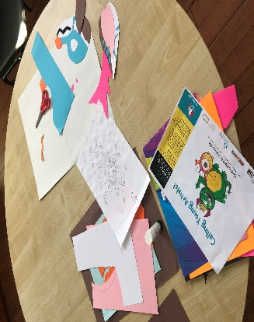  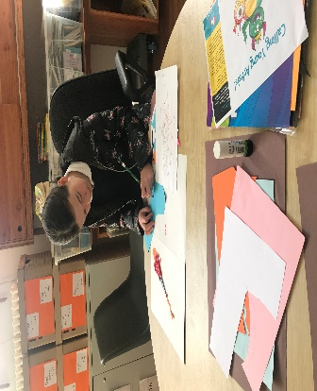  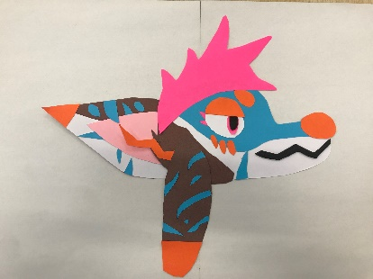  Inchicore Works 175th Anniversary  Inchicore Works are celebrating their 175th anniversary this year and to celebrate this event they are running an artwork competition to design the side of one of their Dart trains. All classes from J Infants to 6th are very busy working on their artwork for this exciting project.  Calendar for Sports Days  J Infants – Tues. 22nd June  S Infants (Ms Bohan)  Fri. 25th June  S Infants (Ms Gillespie)  -To be confirmed  1st Class Wed. 23rd June  2nd Class (Ms Ward)  Wed. 23rd June  2nd Class Mr Keane  -To be confirmed  3rd Class Tues. 22nd June  4th Class Fri. 25th June  5th Class Thurs. 24th June  6th Class Thurs. 24th June  2020  2020 you were quite something, you were the year for the bird’s broken wing.  Tears were shed, many were dead.  George told to get off his neck, he couldn’t breathe, black peoples wreck.  The virus told us to wear a mask, but didn’t politely ask.  Tears were cried, many died. That’s what the internet said, maybe they lied?  Schools closed down, so did the town, but where was learning oh yes that was your house.  What’s that you hear? Fake news I say-that started to spread on the 21st of May.  I feel sick, unsteady, maybe it’s the flu? Oh, hopefully I dint pass it all through to you!  We were all hurt, pained and put on mute, it stung it burned, it played like the flute.  Zoom calls happened and tables were tappened. Classes were skipped, social skills were ripped.  Going on holiday? Stop right there! The government says no, I know it’s unfair.  We all miss our uncles, aunties, cousins and grannies. I know it’s not the same over the phone, but thank you so much for the patience you’ve shown!  By Katie McGeough  5th Class

