Inchicore NS Active Homework
20th – 24th June 2022
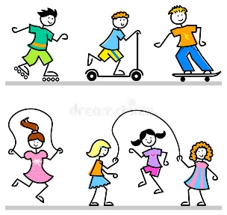
Colour in the activity once it’s been done!
Cycle your bike  10 minutes | 10 squats & 15 lunges | Just dance activities  10 minutes | Run laps in your back garden  5 minutes
Walk your dog with a family member | Go to the playground | Go Noodle  10 minutes | Create your own obstacle course
Create a dance to your favourite song | Go for a jog with a family member | Practice a skill eg kicking  10 minutes | 20 jumping jacks
Go swimming with your family | Ride your scooter  10 minutes | Go for a walk 15 minutes | Throw and catch a ball with someone  5 minutes
20 sit ups | Skip  2 minutes | Play tag | Kick a ball with someone  10 minutes
Every child needs 60 MINUTES of physical activity every day to be healthy. (World Health Organisation)
__________________
Pupil signature
__________________
Parent signature

